***Project Management***

Assessment ONE

18426 Narusorn phuphanab

|  |  |  |  |
| --- | --- | --- | --- |
| Name of Student | Narusorn Phuphanab | ID | 18426 |

**Assessment 1 – Case Study**

Contents

Instruction: 1

Duration: 1

Case Study: 2

Going Green application, Green IT Project Management 2

Project profile 2

Business situation 5

Your tasks: 5

Task 1: Identify Business Strategy and Gap 5

Task 2: Recommend a feasible solution 6

Task 3: Produce a Project Charter 6

Task 4: Project Document 7

Task 5: Project Closure 12

Search Index 15

## Instruction:

This task is to be completed individually. You need to analyse a case scenario and complete all the tasks mentioned after the scenario.

You need to demonstrate your IT project management ability to identify business strategy and gaps. You will also need to suggest a feasible solution to overcome identified gaps and produce a project charter along with a WBS to implement the proposed solution.

### Duration:

Trainer will set the duration of the assessment.

All my working could be checked at: <https://narusorngit.github.io/pm18426/>

## Case Study:

### Going Green application, Green IT Project Management

# Project profile

Going “Green” is a mission of many companies around the globe not just for reasons of environmental responsibility, but also for cutting costs in these extremely tight economic times. Green IT efforts represent a specific focus area within enterprises that hold attention to this trend. Green IT leverages information technology to streamline operations, cut costly waste, and reduce the impact on the environment. IT typically consumes only about 10% of an organization’s energy costs, but the net effect of a Green IT project is to go beyond just energy saving. To tackle the other 90%, a Green IT project extends into a variety of other departments, and to execute such an endeavour requires an effective project management function in order to identify and prioritize goals. A Green IT transformation can be a complex process.

Vital Statistics:

* Number of project tasks - 12
* Project duration - 16 months
* Project budget - $1,200,000
* Number of users - 50

**This example project is a scenario that I know well and be able to demonstrate the overview of the project.**

**I use Google Sheet instead of Ms-Project to create a Gantt Chart by Link URL:** [**https://docs.google.com/spreadsheets/d/1CvPuS9HNesgjoEO5XAy8Yu28m5KRVIx_Nue8WmSwR84/edit?usp=sharing**](https://docs.google.com/spreadsheets/d/1CvPuS9HNesgjoEO5XAy8Yu28m5KRVIx_Nue8WmSwR84/edit?usp=sharing)

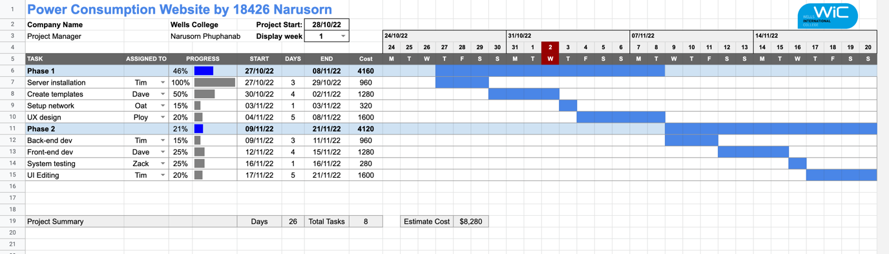

Tutor reference: <https://www.youtube.com/watch?v=8eKk0M2zGIk>

Or using GanttProject software:

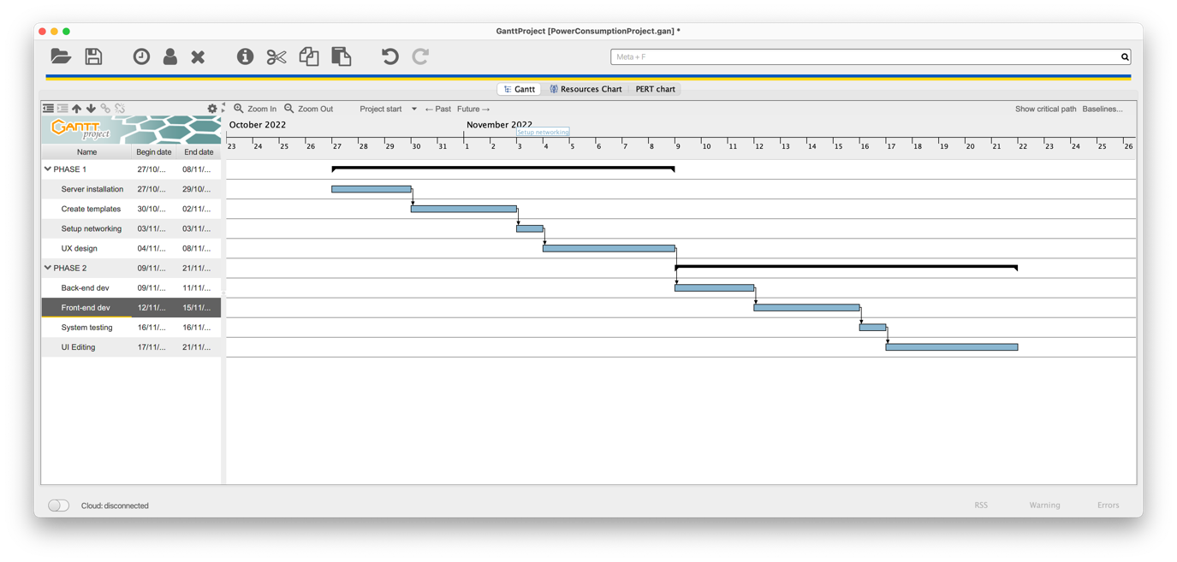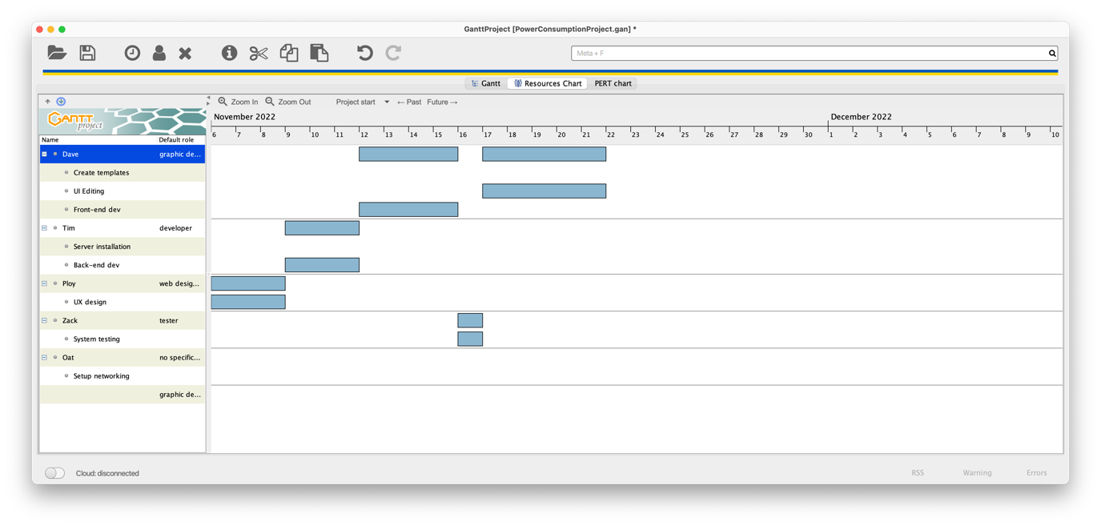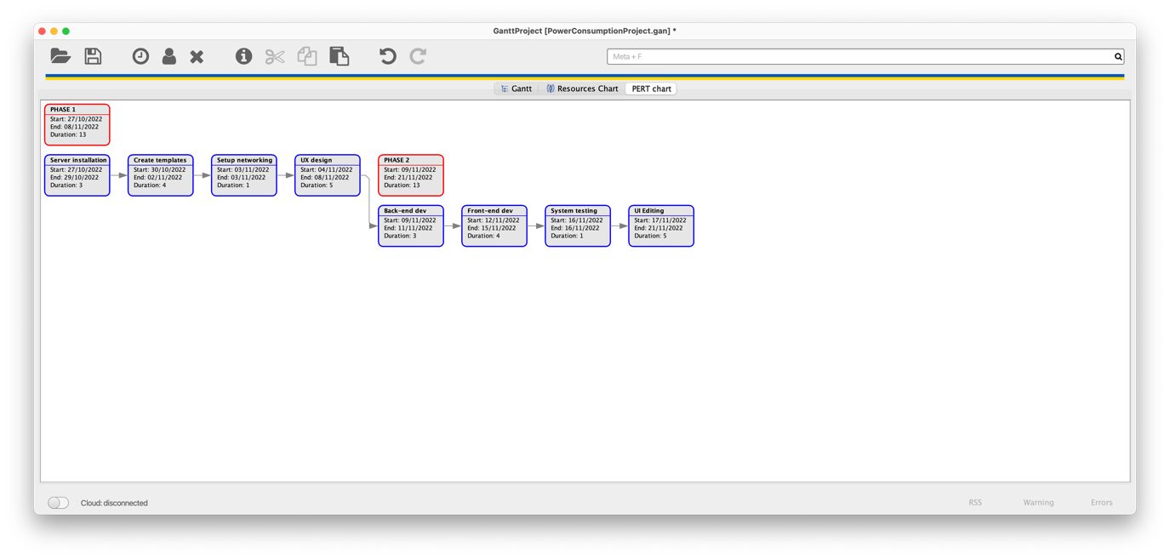

My GanttChart Website Link: <https://narusorngit.github.io/pm18426/GanttProject/PowerConsumptionProject-chart.html>

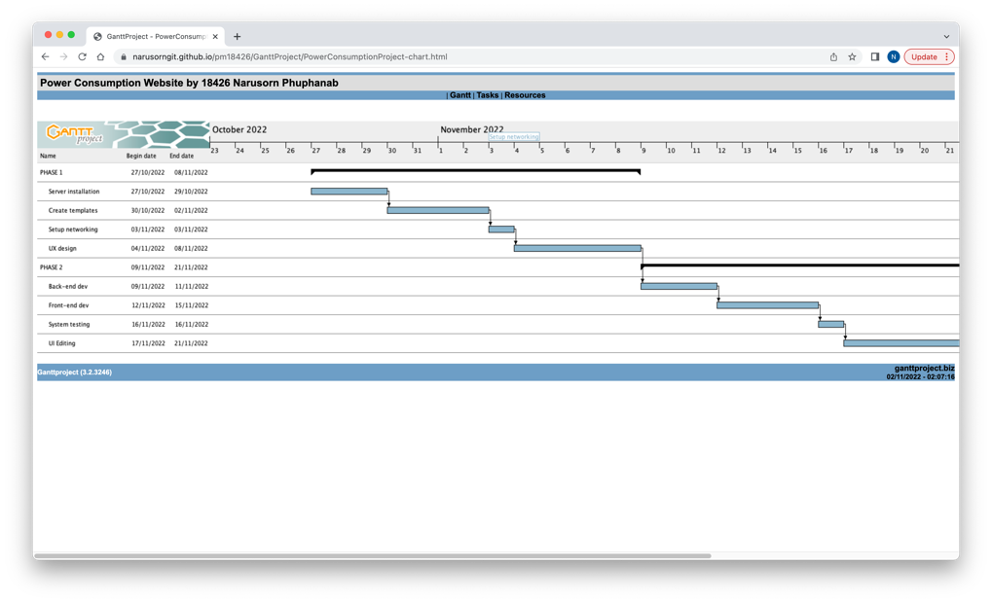

Online Support Website : <https://narusorngit.github.io/pm18426/>

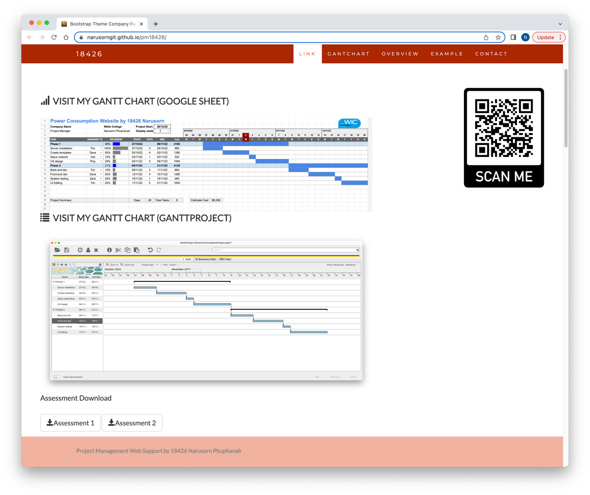

### Business situation

***Power Consumption - Project Overview***

***Project background:  
Building manger is not able to know or track power and lack of control on their unnoticeable energy leak and used to manage power when the power bill is finalised monthly.***

***In order help college facility building management, the college need an infographic dashboard to track power usage of the building.   
This software will help the facility department to indicate unnecessary use of energy within the building. The building manager can use this software and get notifications or alarms on each section of the building. Moreover, this software will be collecting data and be able to export a report file to manage on power usage plan and maintenance plan.***

***Example User Interface:***

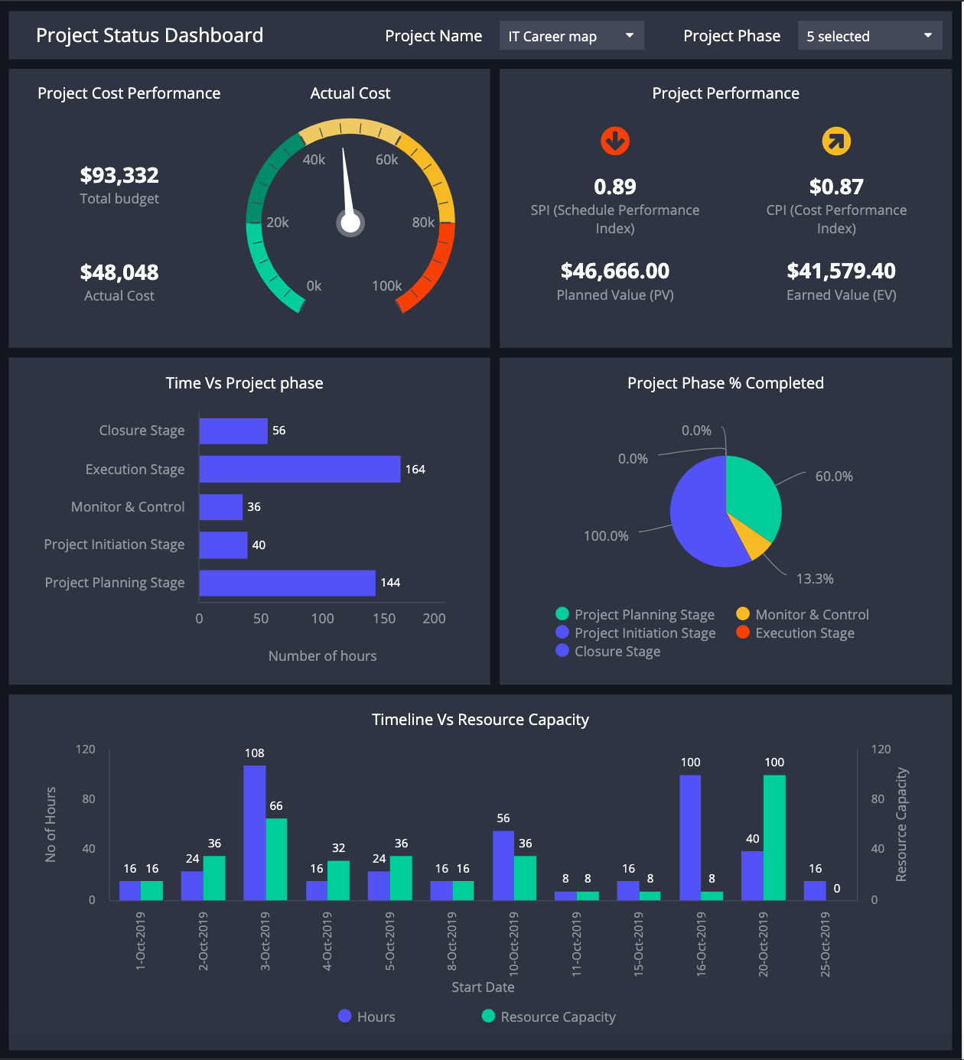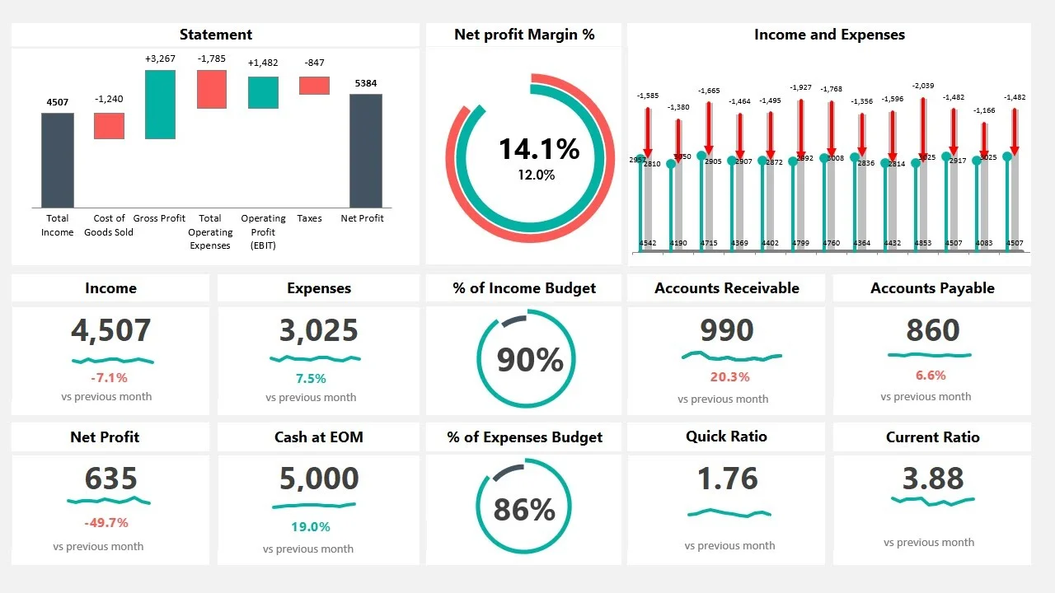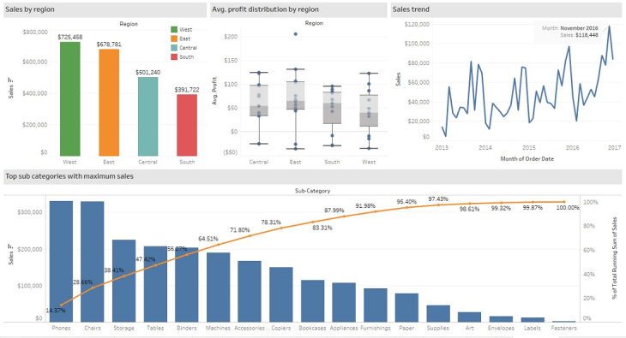

***Also, The Project Management support website has been made to estimate budget and cost that will be used in the project. And show human resources and tasks easy to manage and contact when there is something unpredictable or project being late.***

## Your tasks:

### Task 1: Identify Business Strategy and Gap

Document the business’s strategies of “Green IT” and also summarise the components required changes for the participating organisation to implement “Green IT Project”. (Min. 300 words)

Business strategy is a planning function of any organisation. Business strategy incorporates having a strategic plan.

**Analyse Strategy**

The strategic plan of an organisation sets out the goals a business hopes to achieve within a specified period of time. It also helps the organisation understand the environment within which they operate and the market forces that affect them.

An analysis of the current strategic plan enables you to understand the goals of your organisation. However, in order to analyse the strategic plan, you first need to understand the structure and purpose of a strategic plan. This topic describes the elements that make up a strategic plan.

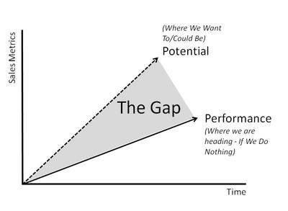The green project we need defined every requirement. The gap which is between your plan and reality always need your notice. So you need do your best to investigate your Green Project.

### Task 2: Recommend a feasible solution

Assume “Wells International College” is thinking of going “Green” and asked for your assistance in this project. Research different project management applications on the Internet to compare with the Green IT project management application and recommend a feasible solution with proper reasons for Windsor. (Min. 300 words)

### Task 3: Produce a Project Charter

Please view my project charter (here only show part):

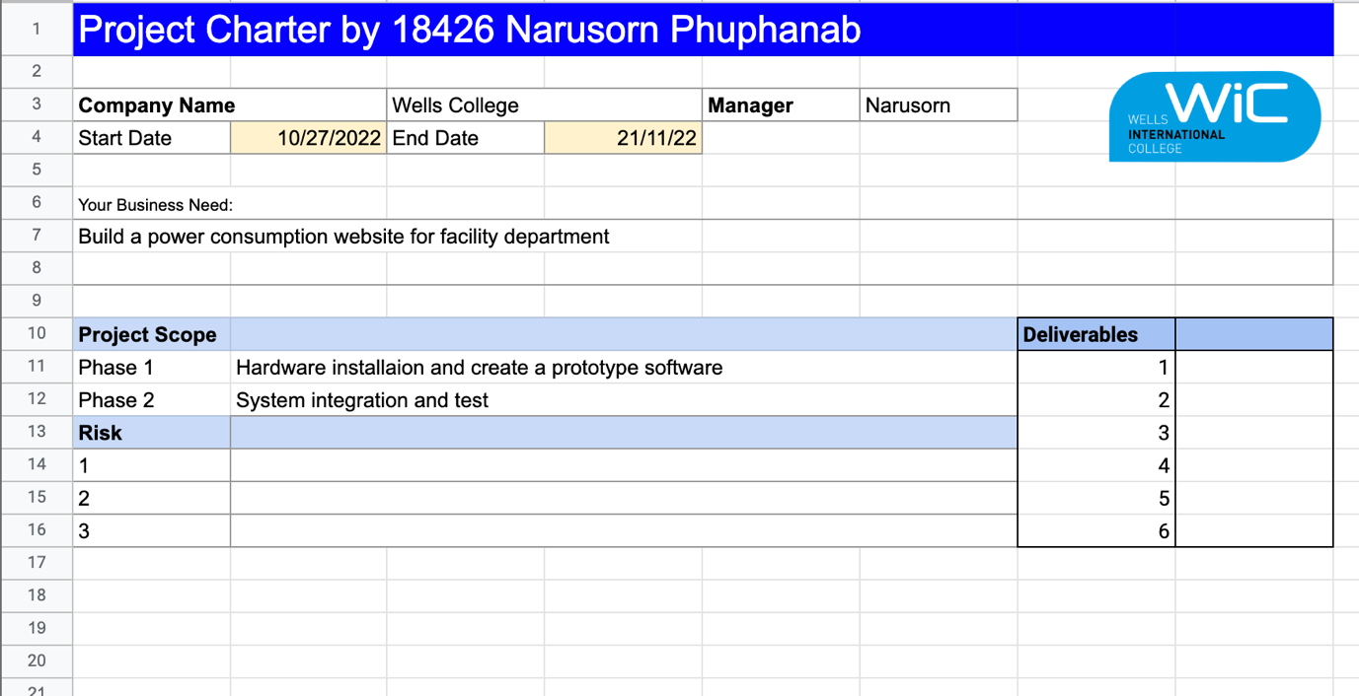

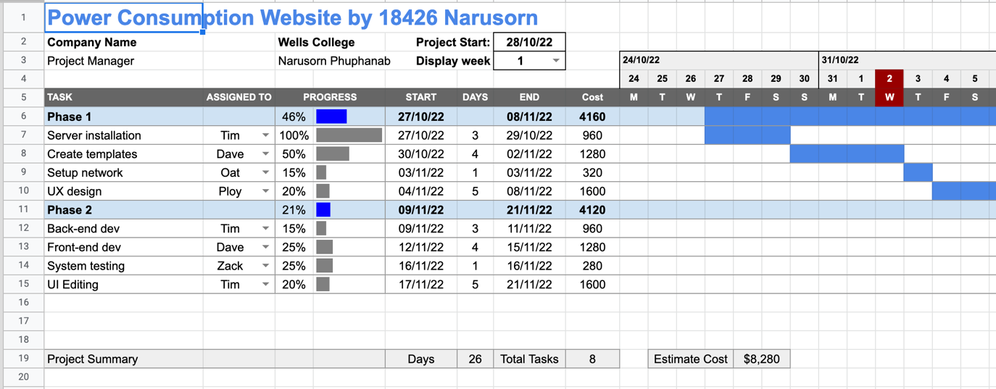

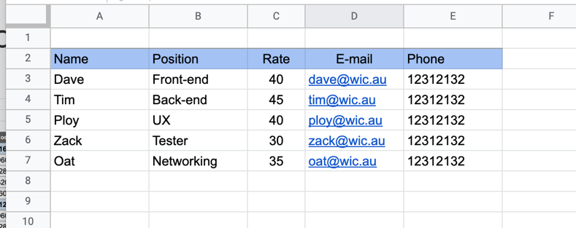

### Task 4: Project Document

Please check my site: <https://narusorngit.github.io/pm18426/>

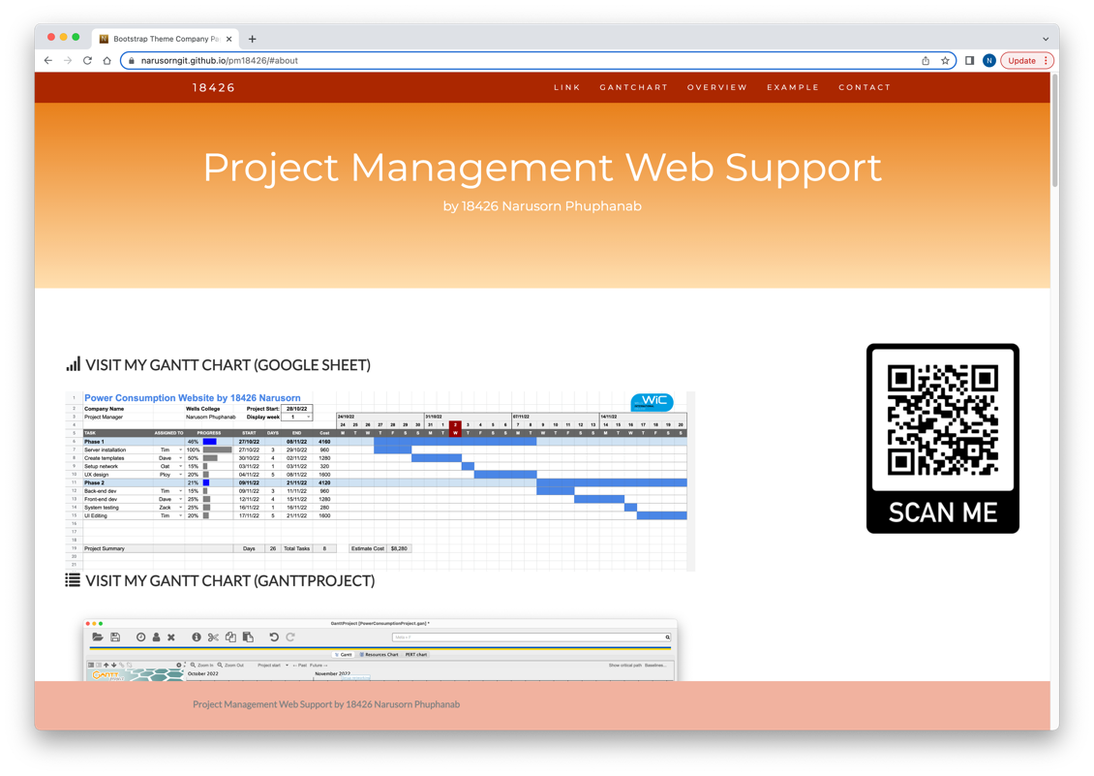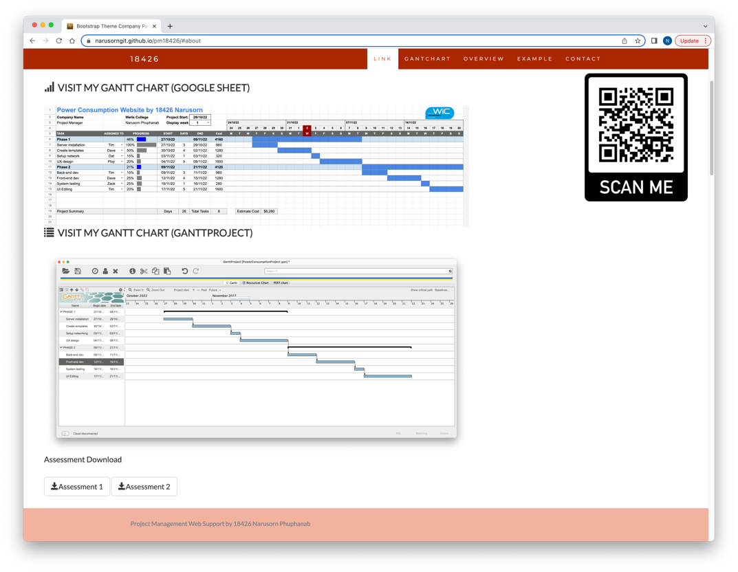

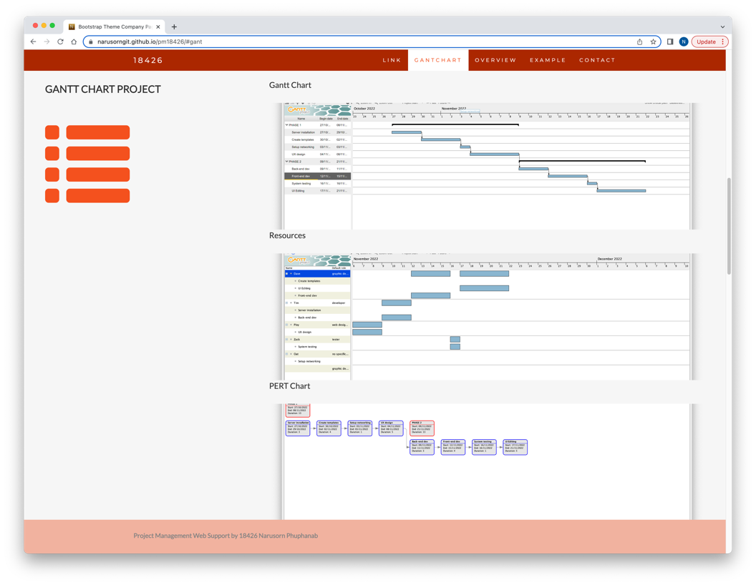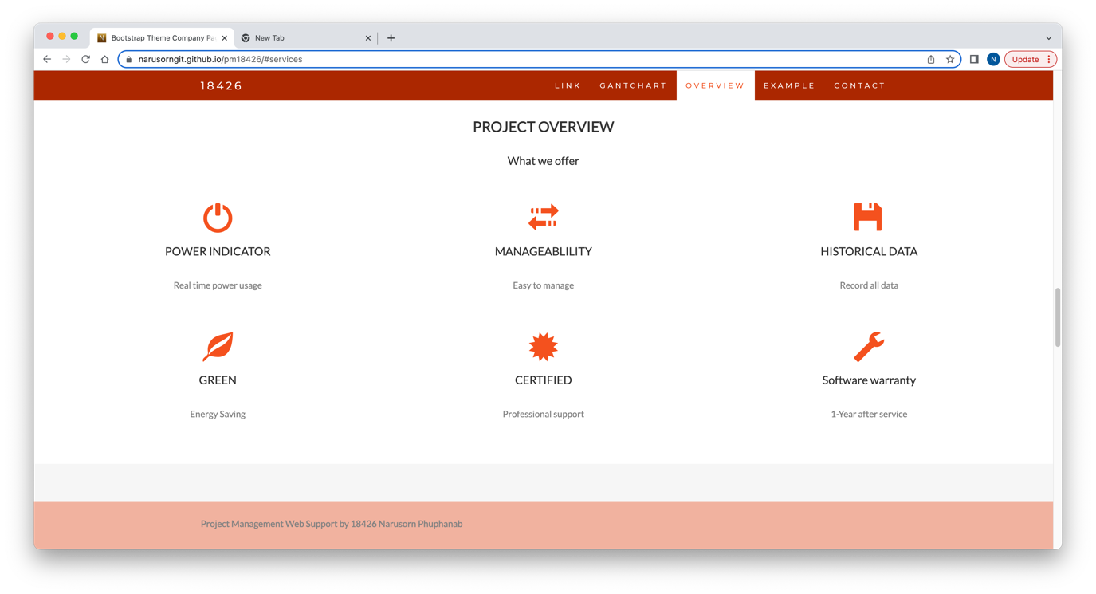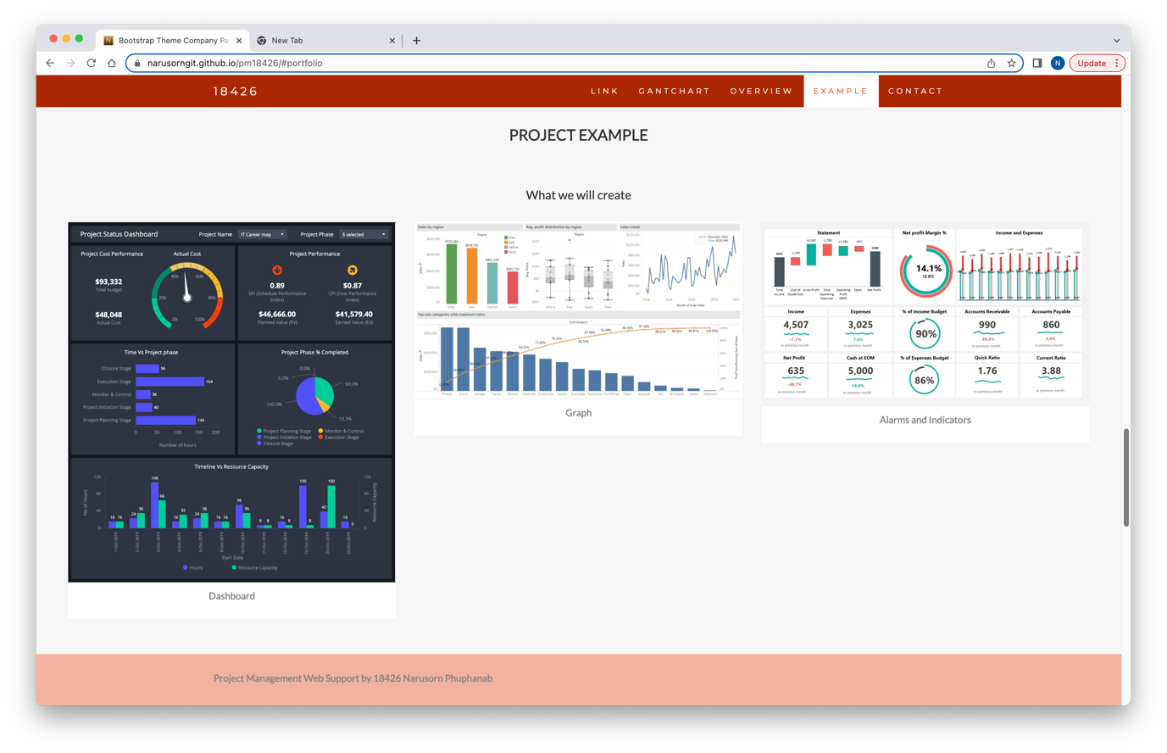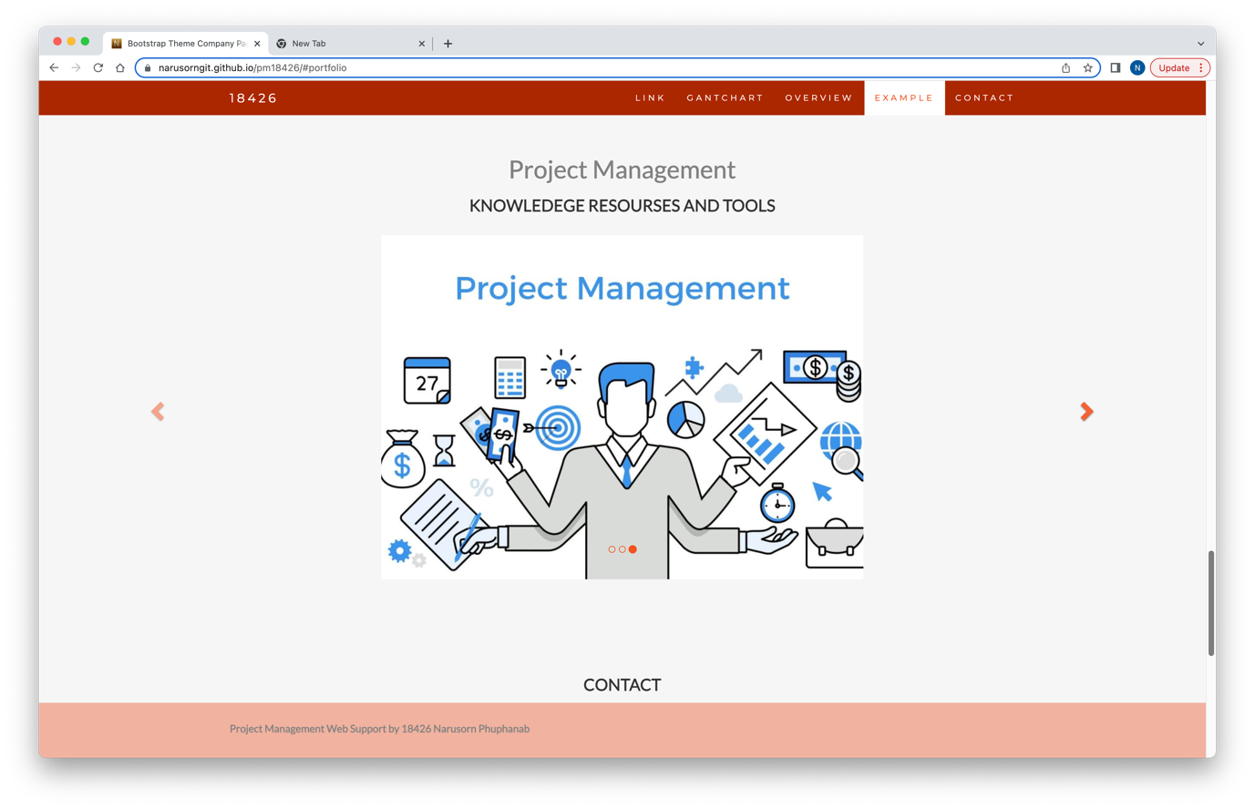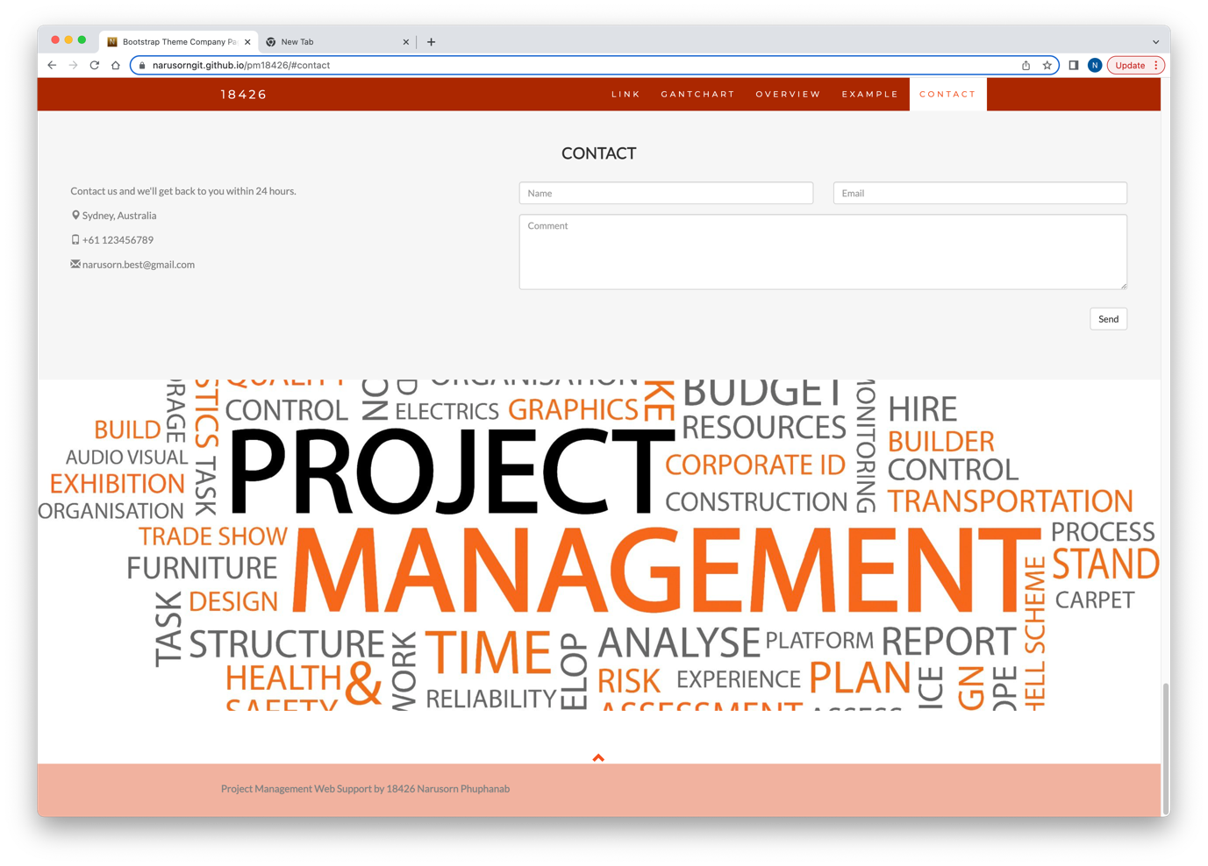

Refer to your current project, you have been asked to develop a project plan for WIC. Project plan outline as following:

In my Green project, I design following topics:

* Introduction (Select one recommendation from Task 2 for implement project plan)
* Project background
* Related factor to organization
* Scope and objective of the project
* Information gathering plan and approach
* Gathering method, can be one of the following
* Interview
* Questionnaire
* Observation
* Detail of information repositories
* Feasibility studies
* Technical
* Operational
* Economical
* Social
* Project plan and schedule (Development and Maintenance)
* Work breakdown structure
* Gantt Chart
* Milestone
* Project Deliverable
* Communication plan
* Deployment Plan (If needs)
* Training Plan (If needs)
* Recourse and budget, (budget has been limited by WIC Capital Expenditure of current fiscal year for Hardware $80,000, Software $10,000, and Outsourcing man-hours $100,000)
* Risk Management
* Risk identified
* Contingency plan
* Change management
* Change control
* Conflict management

### Task 5: Project Closure

Prepare project closure document template as following:

* Project Sign-off document

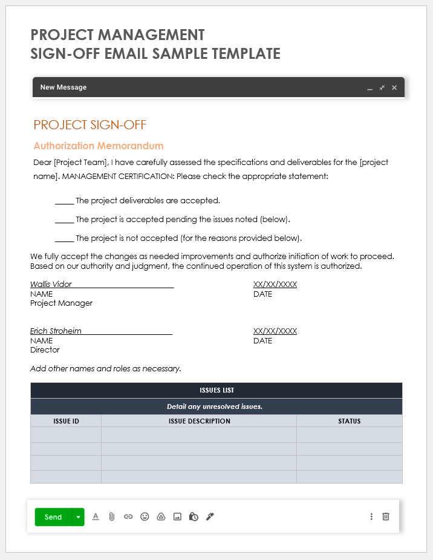

*Refer source:* [*https://www.smartsheet.com/content/project-sign-off-templates*](https://www.smartsheet.com/content/project-sign-off-templates)

* Project evaluation document

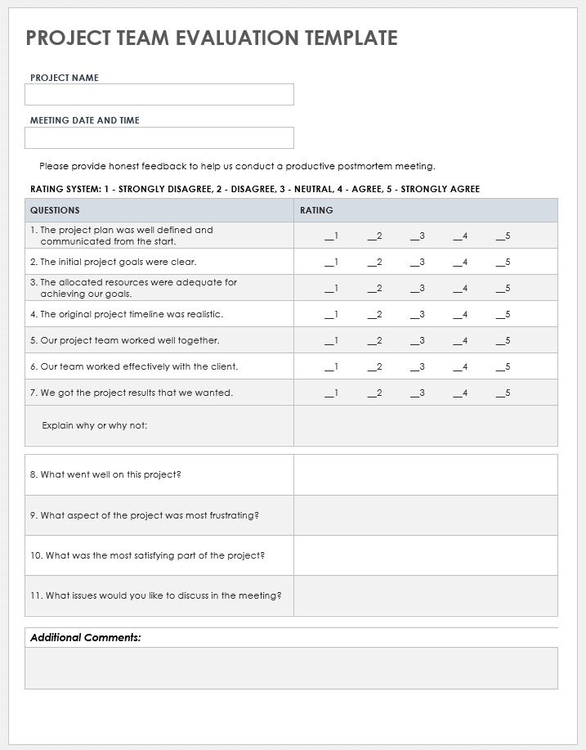

*Refer source:* [*https://www.smartsheet.com/content/project-evaluation-templates*](https://www.smartsheet.com/content/project-evaluation-templates)

* Lesson learned template

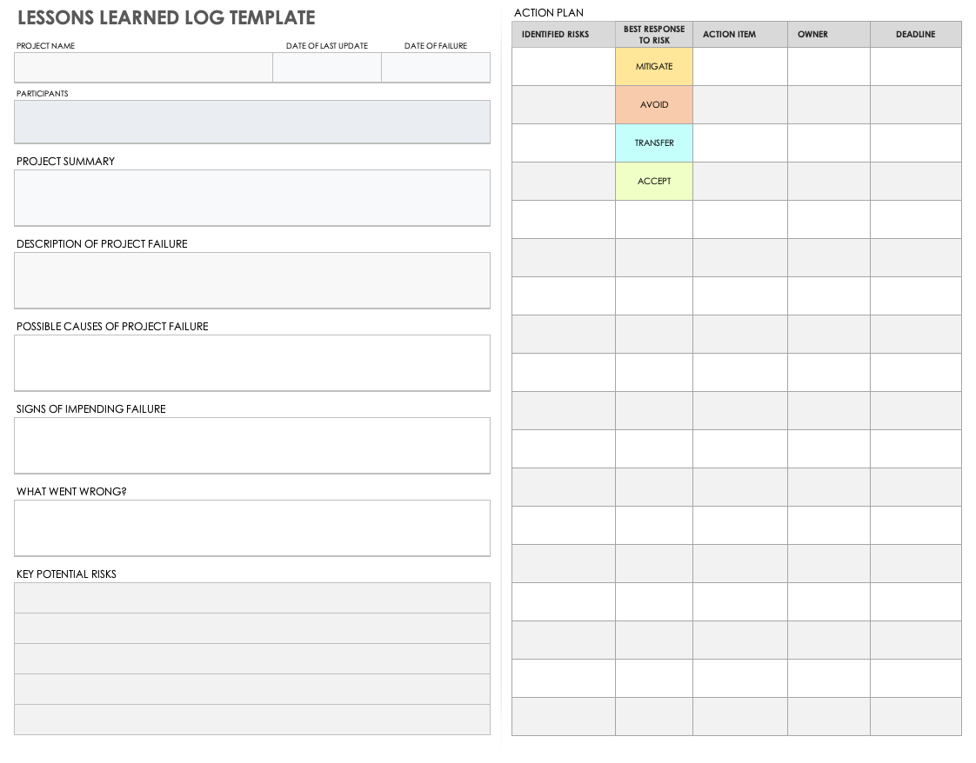

*Refer source :* [*https://www.smartsheet.com/content/lessons-learned-template*](https://www.smartsheet.com/content/lessons-learned-template)

## Search Index

B

Benefit evaluation 10

Budget evaluation 10

F

feasible solution 1, 4

P

project sign off 9

Q

Quality evaluation 10

S

same mistake 10

scenario 1

specific focus 2